14.10: a) The pressure used to find the area is the gauge pressure, and so the total area is
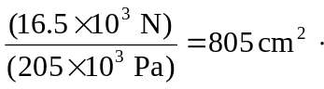
b) With the extra weight, repeating the above calculation gives 

